UEENEEG107A Final Revision Sheet KEY

SECTION A – Multiple choice
Instructions:
Select the response you consider best answers each question by placing an X in the appropriate box on the multiple choice answer sheet located at the end of section A. You may select as an answer either A, B, C or D. You can only select one answer for each question.

- In accordance with AS/NZS 3000, if a circuit breaker is used to protect a conductor against overload, which two conditions must be satisfied?
(a) I_{Z} ≤ I_{N} ≤ I_{B;} and I₂ ≤ 1.45 x I_{Z}
(b) I_{B} ≤ I_{N} ≤ I_{Z;} and I₂ ≤ 1.45 x I_{Z}
(c) I_{B} ≤ I_{N} ≤ 0.9 I_{Z;} and I₂ ≤ 1.45 x I_{Z}
(d) I_{B} ≤ I_{N} ≤ I_{Z;} and I₂ ≤ 1.6 x I_{Z}
- The maximum permissible voltage drop in an installation where the substation feeding the installation is not installed on the premises and the voltage at the point of supply is 230 Volts is:
(a) 11.5 volts
(b) 12 volts
(c) 20 volts
(d) 20.75 volts
- Which of the following installation conditions would NOT require the current carrying capacity of the cable to be de-rated?
(a) Parallel connected cables installed as a single circuit
(b) A single circuit buried at a depth of 0.6m with a soil temperature of 25°C
(c) A single circuit installed in air at 40°C protected by a circuit breaker
(d) A single circuit installed in air at 40°C protected by a HRC fuse
- The functional switch used to control a 6.5 kW fixed cooking appliance (electric range) that connects to two-phases and neutral, would have as a minimum of:
(a) One pole
(b) Two poles
(c) Three poles
(d) Four poles
- A TPS wiring system installed within a PVC conduit in a concrete floor on, or above the ground would be deemed to have the same current carrying capacity as cables installed:
(a) Enclosed in air
(b) Buried direct in the ground
(c) Unenclosed in air
(d) Enclosed in underground enclosure
- The mean tripping current (I_{A}) that causes automatic operation of a type C circuit breaker within 0.4 seconds, is:
(a) 1 x the rated current (the nominal current rating)
(b) 4 x the rated current
(c) 7.5 x the rated current
(d) 12.5 x the rated current
- A suitable device that may be used to prevent physical injury during mechanical maintenance of an electrically actuated machine would be a/an:
(a) emergency stop button
(b) start / stop station
(c) functional switch
(d) isolating switch
- Two circuits run as a group are wired with 2.5 mm² TPS twin and earth cable and are clipped to the side of the ceiling joists in a domestic installation where bulk thermal insulation is installed. These circuits would be classified as:
(a) unlikely to be disturbed
(b) enclosed in thermal insulation
(c) totally surrounded by thermal insulation
(d) partially surrounded by thermal insulation

- The two points in an electrical installation from where the maximum permissible voltage drop is considered:
(a) Is between any two points in the installation
(b) Is between the point of supply and the main switchboard
(c) Is between the point of supply and any other point in the installation
(d) Is between the main switchboard and the furthermost final sub-circuit

- For the requirements of the NSW Service and Installation Rules, the maximum number of customers that may be connected to an 80 A meter protection fuse is:
(a) 1
(b) 2
(c) 4
(d) No limit
- If a three-phase installation (single tariff) has a maximum demand that exceeds 100 A per phase:
(a) CT metering must be installed
(b) Whole current metering must be installed
(c) Off-peak meters must be installed
(d) 125 Amp relays must be installed
- A single phase, single domestic installation not exceeding 100A has a 400 litre hot water tank that the customer wants connected to the off-peak tariff. A suitable metering arrangement for the switchboard would be:
(a) CT metering, an off-peak meter and a load control relay
(b) A Polyphase whole current meter, an off-peak meter and a load control relay
(c) A single phase whole current meter, an off-peak meter and a load control relay
(d) Time-of-use metering

- When installing energy meters in low voltage installations not exceeding 100 A per active conductor, you must ensure the:
(a) top edge of the meter is no more than 1.8 m above the ground, floor or platform and the bottom edge is at least 0.6 m above the ground, floor or platform
(b) top edge of the meter is no more than 2 m above the ground, floor or platform and the bottom edge is at least 0.3 m above the ground, floor or platform
(c) top edge of the meter is no more than 2 m above the ground, floor or platform and the bottom edge is at least 0.5 m above the ground, floor or platform.
(d) top edge of the meter is no more than 2.2 m above the ground, floor or platform and the bottom edge is at least 0.5 m above the ground, floor or platform

- The minimum current rating of an installations service neutral link must be:
(a) 63A
(b) At least equal to the current rating of the Main Switch
(c) 100A
(d) At least equal to the current carrying capacity of the incoming main neutral conductor

- An installation that would qualify for connection to the ‘general / business’ tariff would be a:
(a) storage warehouse
(b) domestic home office
(c) multiple domestic block of home units
(d) residential living units on a university campus

- Generally, the maximum height above ground, floor or platform which a main switch may be installed on the main switchboard is:
(a) 1.2 metres
(b) 2.0 metres
(c) 2.5 metres
(d) 3.0 metres

- In NSW, the nominal prospective short circuit current at the connection point for low voltage services up to 400 Amps in suburban residential areas is:
(a) 6kA unless otherwise advised by the electricity distributor.
(b) 10kA unless otherwise advised by the electricity distributor.
(c) 25kA unless otherwise advised by the electricity distributor.
(d) 30kA unless otherwise advised by the electricity distributor.

- Which device does NOT provide protection from potential injury caused by a short circuit between live conductors?
(a) Circuit Breaker
(b) HRC Fuse
(c) Combination MCB/RCD
(d) Residual Current Device (RCD)

- The maximum permissible disconnection time to provide protection against indirect contact (fault protection) for a circuit supplying 10A socket outlets is:
(a) 1.45 seconds
(b) 30 milliseconds
(c) 5 seconds
(d) 0.4 seconds

- AS/NZS 3000 lists the maximum value of earth fault loop impedance (Z_{S}) for a submain protected by a 63A HRC fuse as:
(a) 0.55Ω
(b) 0.9 Ω
(c) 1.28 Ω
(d) 0.36 Ω

SECTION B – Australian Standards and Wiring Rules
Instructions:
Use AS/NZS 3000, AS/NZS 3008.1.1 and The Service and Installation Rules of NSW to answer these questions.

You must use the rule book indicated by each question to reference your answer.
Clause numbers must be quoted in full, including any sub letters or notes, as expressed in AS/NZS 3000, AS/NZS 3008.1.1 or The Service and Installation Rules of NSW for the relevant answer.

- A 25A single phase socket outlet is wired using 4mm² V90 twin and earth flat TPS cable and protected by a 25A type C circuit breaker. Determine the maximum circuit length to meet fault loop impedance requirements. Use AS/NZS 3000 as a guide.
________67metres________________________________________________________________________________________________________________________________________________________AS/NZS 3000 Reference: ___Table B1____________________________
- A circuit for a fixed or stationary cooking appliance incorporating an open cooking surface must have a functional switch. What three (3) examples of cooking appliances having an open surface, are listed in AS/NZS3000? Use AS/NZS 3000 as a guide.
(1) Cooktop____________________________________________________________
(2) Deep Fat Fryer___________________________________________________________________
(3) BBQ, Griddle_____________________________________________________________________
AS/NZS 3000 Reference: __Clause 4.7.1_____________________________
- Every circuit in an installation must have the provision to be isolated from the supply conductors. Other than the requirements for main switches, what are the general common requirements that must be followed when controlling a group of circuits with a common switch?
Use AS/NZS 3000 as a guide.
Provided that the service conditions allow it, and the appropriate safety measures are maintained, a group of circuits may be isolated by a common switch. ____________________________________________________________________________________

AS/NZS 3000 Reference: __Clause 2.3.2.1.1_____________________________

- Specify the four (4) acceptable methods of protection against indirect contact.
Use AS/NZS 3000 as a guide.
- Automatic Disconnection___________________________________________________________
- Class 2 Electrical equipement_______________________________________________________
- Electrical seperation_______________________________________________________________
- Limit fault Current_________________________________________________________________
AS/NZS 3000 Reference: ___Clause 1.5.5.2____________________________
- How many amps (A) are required to flow through a 10A HRC fuse to ensure effective operation (I₂) of the fuse in conventional time (1 hour)? Use AS/NZS 3000 as a guide
___16amps__________________________________________________________________________
____________________________________________________________________________________
AS/NZS 3000 Reference: __Clause 2.5.3.1 or B3.2.1____________________________
- To protect against injury from mechanical movement, motors shall be provided with switching devices capable of performing what functions? Use AS/NZS 3000 as a guide.
- Starting and Stopping_____________________________________________________________
- Emergency Stopping______________________________________________________________
- Isolation for the motor for Electrical and mechanical maintenance___________________________
AS/NZS 3000 Reference: _Clause 4.13.1.1 or 2.3 ______________________________
- Calculate the AC resistance of a 50metre length of 16mm² single core copper conductor operating at 75°C. Use AS/NZS 3008.1.1 as a guide.
(1.4 x 50) ÷ 1000 = 0.07Ω______________________________________________________________
____________________________________________________________________________________
AS/NZS 3008.1.1 Reference: ___Table 34 column 4_________________________

- An oven circuit is wired using 6mm² V90 copper twin and earth flat TPS cable. Determine the current carrying capacity of the cable if it is wired through the ceiling space in a domestic installation clipped to a ceiling joist. The cable is installed as a single circuit and is protected by a circuit breaker.
Use AS/NZS 3008.1.1 as a guide.
Table 3(2) Item 9 Partially Surrounded_________________________________________________
Table 10 column 15 35amps _______________________________________________________
AS/NZS 3008.1.1 Reference: _Table 3(2), Table 10 column 15___________________________

What vertical clearance and minimum horizontal clearance is required for the accessibility of service equipment?
Must provide a vertical clearance of not less than 2 metres from ground, platform or floor and a minimum horizontal clearance of not less than 0.6 metre from the equipment mounted on the hinged panel or external front edge of the switchboard enclosure ( which ever protrudes the most).__________________
The Service and Installation Rules of NSW Reference: _Clause 4.2(c) page 78______________

A meter box and Main Switchboard has been installed on the side wall of a single domestic premise, 2 metres from the front face of the house.
In general, is this location permitted? Yes / No __________________________________________
Explain your answer: Why / Why not Cause the Service Rules says so and it’s beyond 1.5m ____

Use The Service and Installation Rules of NSW as a guide.
The Service and Installation Rules of NSW Reference: _Clause 4.2.1 (b)_______________________

SECTION C – Calculations
Instructions:
You must show all relevant working in the spaces provided justifying your answer.
Note: For many cable sizes (CSA) you will find that the Current Carrying Capacity (CCC) and the Vc value (mV/a.m) will be identical across multiple selection tables within AS3008.1.1.
.

A 400-volt, three-phase final sub-circuit in a non-domestic installation consists of three X90, single-core, thermoplastic and sheathed copper conductors, laid flat touching, supplying a 50-ampere resistive load. The distance from the switchboard to the load terminals of the equipment is 41 metres.
Calculate the minimum permissible cable size if the voltage drop in this cable segment is not to exceed 2.5%.
Show working:
1000 Vp
Vc
L x I
1000 x 10

41 x 50
4.878 mV/A.m
=
=
=
Vp 2.5% x 400
10 V
=
=

Table No: __41________________________
Conductor size: *__10mm²__________________

Calculate the voltage drop in each segment of a three-phase, 400 volt non-domestic installation consisting of the following:
(a) Consumer main:
Phases: 3
Maximum demand: 63 A
Circuit length: 30 m
Cable size: 25 mm²
Cable configuration: X90 single core thermoplastic and sheathed copper conductors
Cable installation: The circuit is enclosed in heavy-duty rigid thermoplastic conduit with no other circuits, buried in the ground 0.5m deep having an ambient soil temperature of 25ºC.
V_{C} Reference Table No: __41_______________________________
mV/A.m rating (Vc): ____1.62mV/A.m________________________
Volt drop (Vd) calculation: ________________________________
________________________________________________________
________________________________________________________
________________________________________________________
________________________________________________________
(b) Sub-main:
Phases: 3
Maximum demand: 32 A
Circuit length: 26 m
Cable size: 10 mm²
Cable configuration: V90 single core thermoplastic and sheathed copper conductors
Cable installation: The cables are clipped to the building structure in trefoil formation and installed in single circuit configuration, unenclosed in air
V_{C} Reference Table No: __40_______________________________
mV/A.m rating (Vc): ___3.86mV/A.m_________________________
Volt drop (Vd) calculation: ________________________________
Vd = 26 x 32 x 3.86 = 3.21 V_______________
_____________________1000__________________________
________________________________________________________
________________________________________________________

Q 32: (continued)
(c) Final sub-circuit:
Phases: 1
Maximum demand: 20 A
Circuit length: 23 m
Cable size: 2.5 mm²
Cable configuration: V90 two-core and earth thermoplastic and sheathed copper conductors
Cable installation: The cables are clipped to the building structure and installed in single circuit configuration, unenclosed in air
V_{C} Reference Table No: _____42______________________________
mV/A.m rating (Vc): 15.6 x 1.155 = 18.018mV/A.m__________
Volt drop (Vd) calculation: _________________________________
Vd = 23 x 20 x 18.018 = 8.29 V_________________
________________________1000____________________________________________________________________________
_________________________________________________________

- Considering all three portions of the above installation, does the final overall voltage-drop comply with the requirements of AS/NZS 3000?

________________________________________________________________________________________________________________________________________________________________________________________________________________________________________________________________________________________________________________________________________________________________________________________________________________________ Vd% total = 0.765 + 0.8 + 3.6 = 5.2% > 5% Therefore it doesn’t comply
consumer main
3.06
Vd% x 100
400
0.765%
=
=
sub-main
3.21
Vd% x 100
400
0.8%
=
=
final sub-circuit
8.29
Vd% x 100
230
3.6%
=
=
* alternate working

Vd = 3.06 + 3.21 (8.29 x √3) = 20.63V > 20V doesn’t comply
Or
Vd = ((3.06 + 3.21) / √3) + 8.29 = 11.91V > 11.5V doesn’t comply

- The maximum demand current of a sub-mains in a non-domestic installation is calculated to be 70 amperes. The selected cable is 4-core, non-armoured, X90 insulated and sheathed, circular cable with copper conductors. The cable is installed as a single layer clipped directly to an internal wall with three other circuits, touching, open to the air and protected by HRC Fuses.
Use AS/NZS 3008.1.1 to determine a suitable conductor size for the installation.

- Determine the minimum size of the protection device required:
____80 amps_________________________________________________________________________
- List any conditions that require de-rating, including the de-rating factor:
Note: there is provision to record up to 4 de-rating factors. There may not be 4 factors for this scenario.

Condition: _____HRC_Fuse________________ DR Factor___0.9____________
Condition: Bunched CCt’s Table 22 Item 3Col 7 DR Factor____0.75 _________
Condition: _______________________________ DR Factor________________
Condition: _______________________________ DR Factor________________
- Calculate what the minimum current carrying capacity of the cable to be installed would need to be, that would allow for any de-rating if applicable:

_I_{Z} = I_{N} / Derating Factors_____________________________
_ I_{Z} = 80 / (0.9 x 0.75)________________________________
__ I_{Z} = 118.5amps___________________________________
- Determine the minimum required conductor size:
Table No: __14_______________________________________
Column No: __5____________________________________
Conductor size: * _35mm² (137 Amps) __________________

A circuit supplying an upright oven is protected by a Clipsal 32A type ‘C’ circuit breaker. The circuit is 20 metres long and wired in 4.0 mm² V90 twin and earth TPS cable. Answer the following:
Note: Figure 1 may be used to assist in answering this question.
- Under fault conditions, what is the maximum permissible tripping time, in seconds, for this circuit?

__5 secs_________________________
- Calculate the total earth fault loop impedance (Z_{S}) permitted for this circuit.

Z_{S} = U_{o} / I_{a}_____________________
Z_{S} = 230 / (32 x 4)_____________
Z_{S} = 1.797Ω___________________
________________________________
________________________________
Figure 1 – www.clipsal.com
- Calculate the maximum permissible internal earth fault loop impedance (Z_{INT}) for this circuit.

Z_{int} = 0.8 x Z_{ext}__________________________________________________________________
Z_{int} = 0.8 x 1.8__________________________________________________________________
Z_{int} = 1.44Ω__________________________________________________________________

- Calculate the actual resistance of the fault loop for the cable installed for the oven circuit. Use AS3008.1.1 as a guide.
Z_{Act} = (20 x 5.61) / 1000 = 0.112Ω_______________________________________________________
Z_{earth} = (20 x 9.01) / 1000 = 0.182Ω______________________________________________________
Z_{Total} = 0.112 + 0.182 = 0.294Ω______________________________________________________
- Does the oven circuit comply with fault loop impedance requirements?
(Yes / No) *____0.294Ω < 1.0Ω x 0.8 = 0.8Ω Table 8.1_________

Calculate the prospective fault current (in Amps) at the load side of the Service Protection Device (S.P.D.) as shown on figure 2 below.
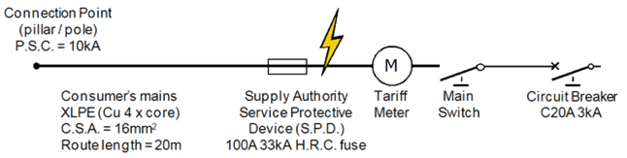
Figure 2

_______________________________________________________________________________________
Supply Impedance Z_{P} = V_{P} / I_{P} = 230 / 10000 = 0.023 Ω
Con Main Impedance R_{Z} = (R_{C} / 1000) x L = (1.47 / 1000) x 20 = 0.0294Ω
(AS3008.1.1 T35 C5)
I _{S/C} = V_{P} / Z_{P} = 230 / (0.023 + 0.0294) = 4389 A _____________________________________________________________________________________
_______________________________________________________________________________________
_______________________________________________________________________________________
_______________________________________________________________________________________
_______________________________________________________________________________________
_______________________________________________________________________________________
_______________________________________________________________________________________
_______________________________________________________________________________________
_______________________________________________________________________________________
_______________________________________________________________________________________
_______________________________________________________________________________________
_______________________________________________________________________________________

SECTION D – Drawings
Instructions:
The following questions in this section require some simple drawing and answering questions relating to the drawings.
- Write your answers to each question in the space provided.
- Ensure that the drawing is neat and legible. You must use a ruler.
- The use of pencil on the drawing is acceptable in this section only.
- You do not need to provide references for questions in this section.
IMPORTANT:
Only provide or draw the information asked for by the question.

The diagram of Figure 3 shown on next page represents metering equipment required to be installed on a switchboard in a single domestic installation.
The installation is to be supplied with 16 mm² unprotected consumer mains.
(a) Draw the following main switchboard wiring required to complete all metering:
  - All meter wiring for the single-phase principle tariff meter through to the main switch;
  - All Off-peak controlled load meter and load control relay wiring through to water heater unit main switch.
(b) Draw the following main switchboard wiring required to complete the MEN connections:
- The incoming supply main neutral conductor;
- The connection between the neutral links;
- The MEN link;
- The switchboard enclosure earthing conductor;
- The main earth conductor.
(c) For the following conductors only, show the minimum size (CSA) of these conductors on the diagram:
- The connection between the neutral links;
- The MEN link;
- The switchboard enclosure earthing conductor;
- The main earth conductor.
Q36 (continued)

Complete the diagram as per the question instructions on the previous page. You must use a ruler.

Note: Nominate the CSA of all cables.

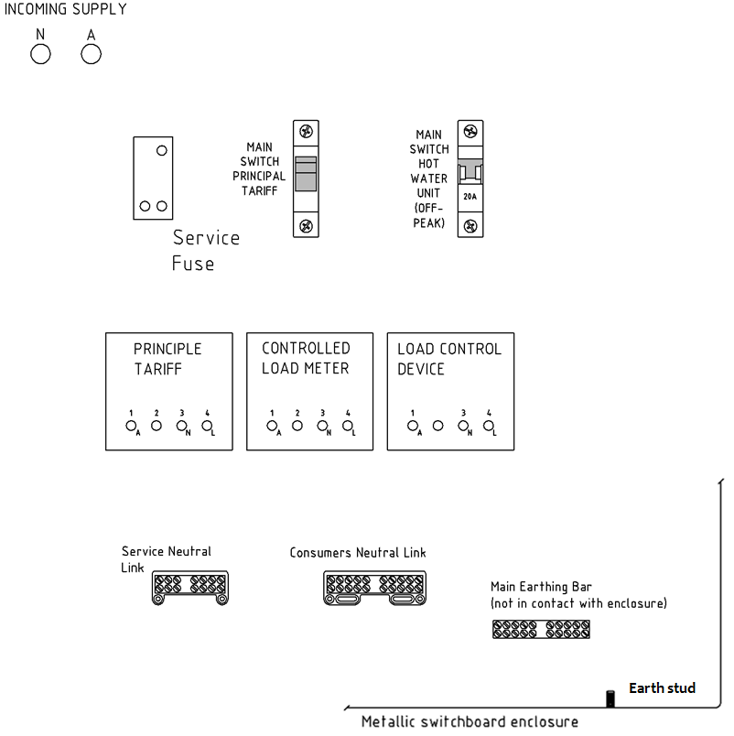
Earth Electrode

Figure 3

- Using the Service and Installation Rules of NSW as a guide, complete figure 4 below by drawing the correct connections for a three-phase installation, which is CT transformer metered. You must use a ruler.

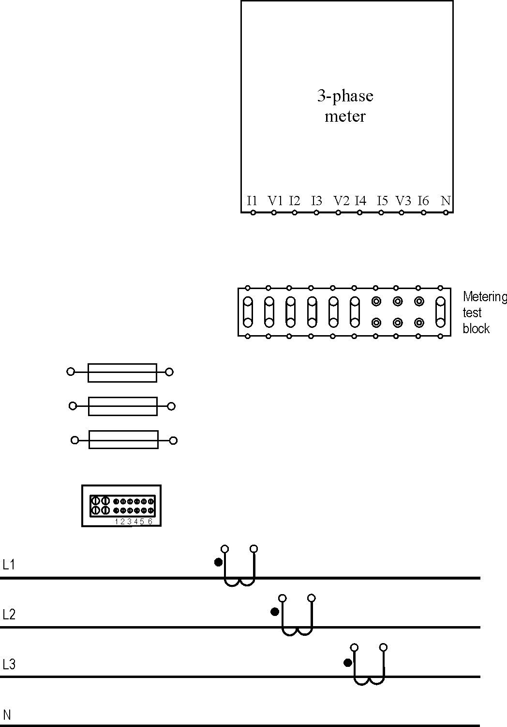
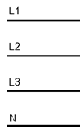
Figure 4

(b) What colours are recommended to identify the current circuit for C-phase of figure 4?

___________________________________________________________________________

- What is the cross sectional area (CSA) of the conductors used to wire the voltage circuit wiring between the supply conductors and potential fuses?

Figure 5 below represents some final sub-circuits for various load types on the main switchboard for a single phase commercial installation.
Complete the diagram of figure 5 by adding the following information to it – You must use a ruler:
(a) Draw the required number of cable connections and main switches required to control the different load types in accordance to AS/NZS3000 standards.
(b) Label all main switches in accordance with AS/NZS3000 standards.

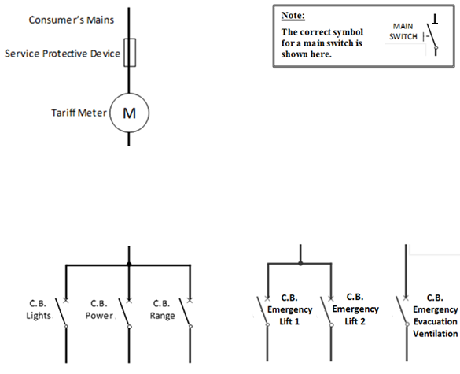

Figure 5

********** END **********

Equation Sheet
This equation sheet is a guide only. Not all equations used in your course are necessarily on this sheet or in the required format.
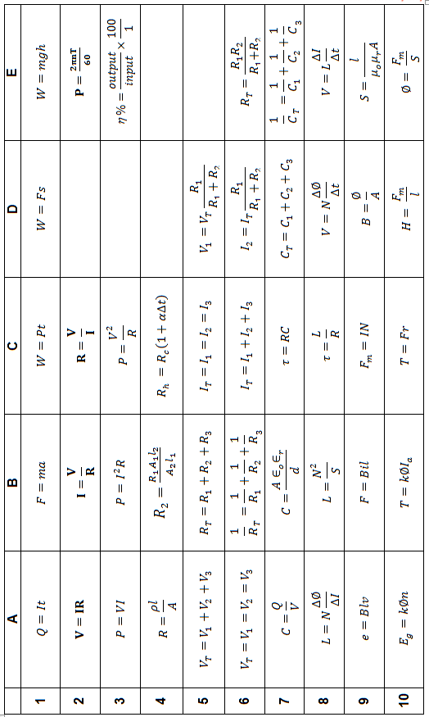

Equation Sheet
This equation sheet is a guide only. Not all equations used in your course are necessarily on this sheet or in the required format.

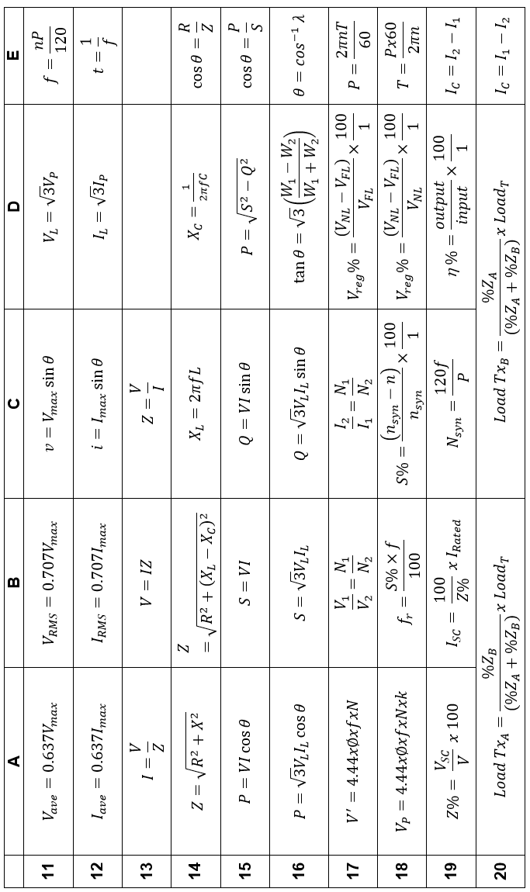

Equation Sheet
This equation sheet is a guide only. Not all equations used in your course are necessarily on this sheet or in the required format.
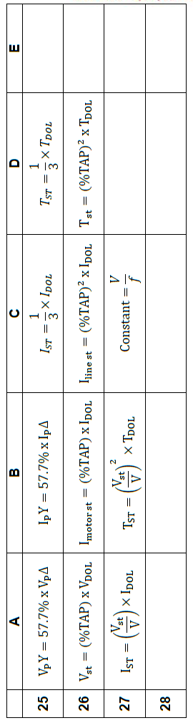
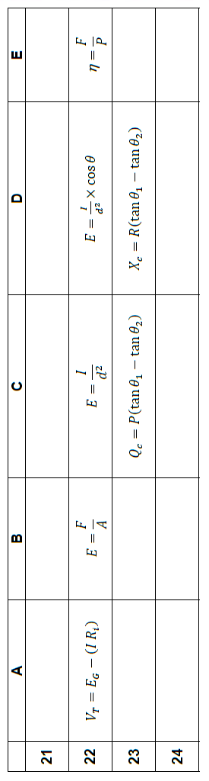

Section A
Answer Sheet

Name: _____________________________ Class: ___________

Place an “X” in the box for the correct answer. If you make a mistake, completely colour in the wrong selection and place an X in the appropriate box indicating your new selection.

 | A | B | C | D
1
2
3
4
5
6
7
8
9
10
11
12
13
14
15
16
17
18
19
20

